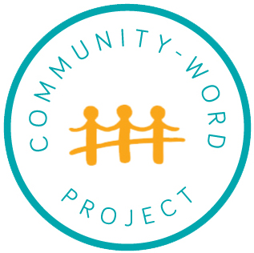

School/ Grade/ CT(s): TAP Advanced Assignment / 9th Grade
Date: Saturday, November 11
Teaching Artists: Philip Berezney, Tessa Raden

Lesson #: 4

Lesson Theme: How can we connect an image to a physical experience?

Inquiry Question(s):
- How do we use our bodies to build confidence in and express our inner selves?
- What can we create using our bodies?

OPENING RITUAL
Objective: Students will get their bodies ready to move creatively and focus their energy.

Activity Name: Body and Breathing Warm Up

Brief Description: Students warm up all parts of their bodies and practice breathing. We reflect on how it felt to warm up our whole bodies in our fingers, toes, faces, bellies, as well as the deep breathing.

INTRO ACTIVITY
Objective: Students will view artworks and generate a list of verbs related to each artwork.
Students practice identifying evidence of action or process within a work of art.

Activity Name: Artwork Verbing

Brief Description: In groups of 6, students view and discuss a work of art. Each group creates a list of 6 verbs in response to their artwork. (Students write each verb on a post-it note.) Guiding questions: What’s happening in the artwork?... How do you think the artist made this?... What did they have to do?... What does it look like is happening in this image?

MAIN EXERCISE
Objective: Students will create sentences to describe actions. Students practice physicalizing ideas, feelings, and identities. Students practice creating and performing tableaux.

Activity Name: Verb Tableaux

Brief Description: Students choose two verbs from their list and write a complex sentence (for example: When we all fall down the rabbit hole, I explode with anger.) Students create two tableaux to physicalize their sentence. Groups present their tableaux to the class. We reflect on the physicalization and presentation experience by connecting those feelings back to the artwork. Guiding questions: “Think about how you felt during this exercise. Which of all the paintings remind you of those feelings? Were you nervous, excited, confused? Which painting reminds you of how you felt?

CLOSING RITUAL
Objective: Students will reflect their energy into the space as a group.

Activity Name: Yes, let’s!

Brief Description: Students spread out in the room. . One student calls out an activity for everyone to start miming (“Let’s play basketball!”), the rest of the group members shout out “Yes, let’s!” and then they act out the activity until someone calls out a new activity. Encourage players to only offer one suggestion until they sense that everyone else has had a chance to play.

Multiple Intelligences Addressed:

Multiple Intelligences
Highlight the intelligences used throughout this lesson plan.

Logical-mathematical; Spatial; Linguistic; Bodily-kinesthetic; Interpersonal; Intrapersonal;
Naturalistic; Existential

Classroom Teacher Role:
Teachers model routines, participate in discussions, and offer one-on-one and small group support to students as needed.

Creative Elements (skill and theme; i.e. ensemble and love)
Force(s): queerness (self-ness), identity, materiality

Craft(s): physicalization, tableaux

Artists/ Authors/ Works of Art (to be presented as models for skills/themes identified above):

Jennifer Packer, Graces

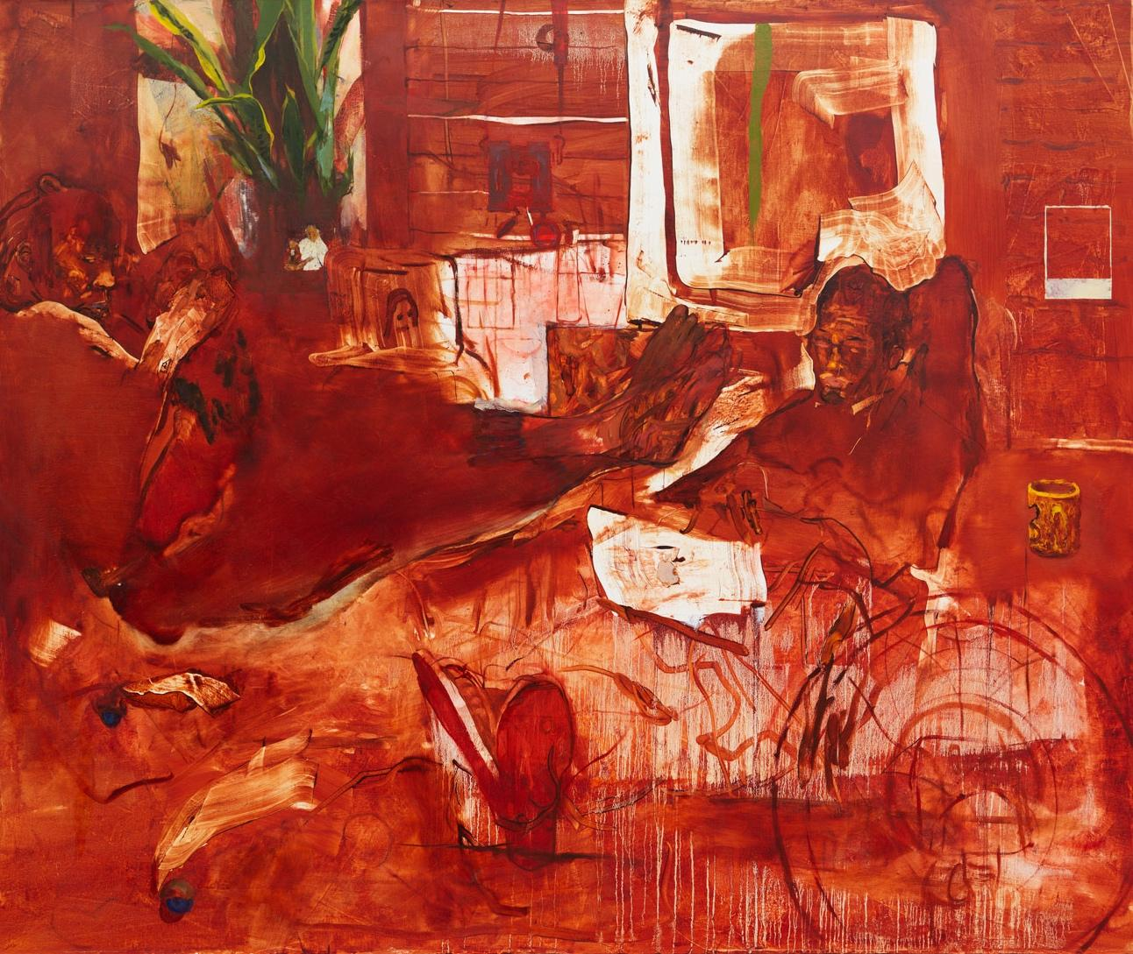

Carlos Almaraz, Purple Crash

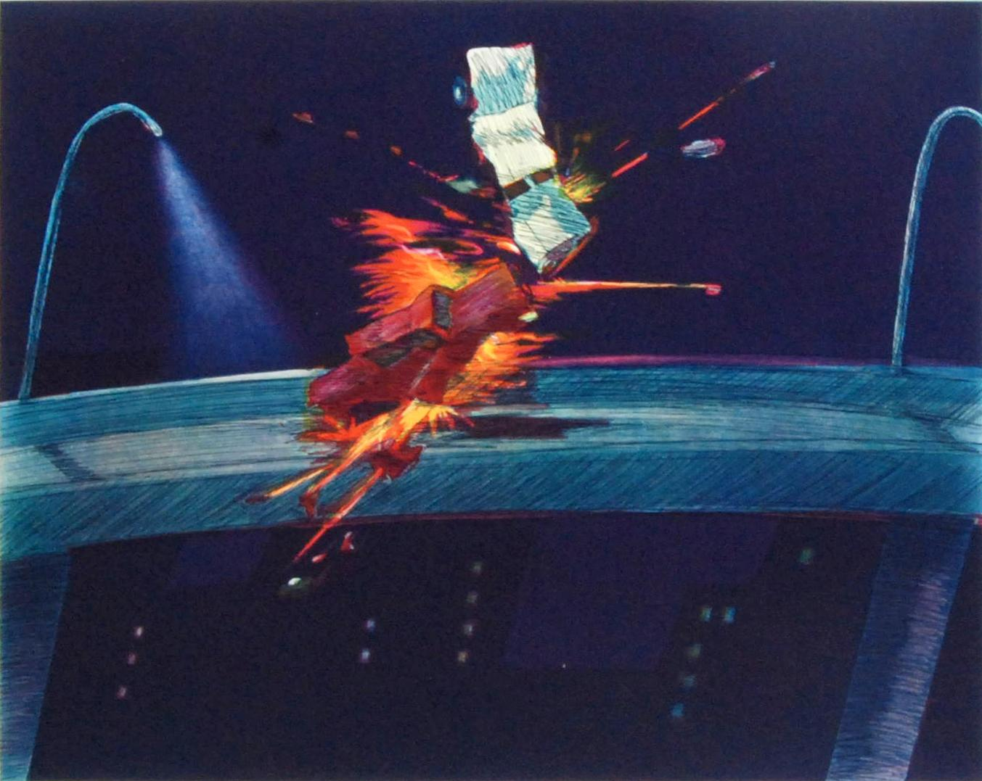

Marsden Hartley, Portrait of a German Officer

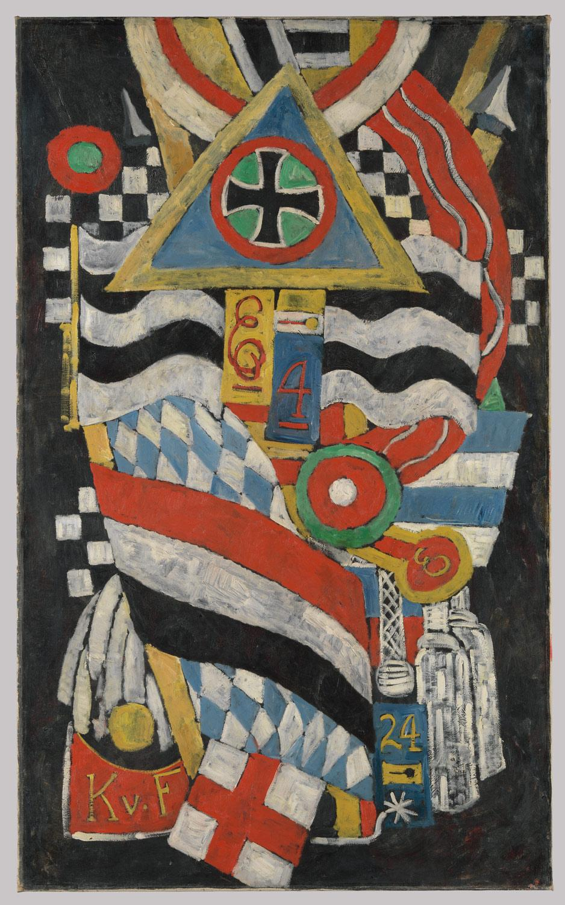

Agnes Martin, Friendship

Julie Mehretu, Bombing Babylon

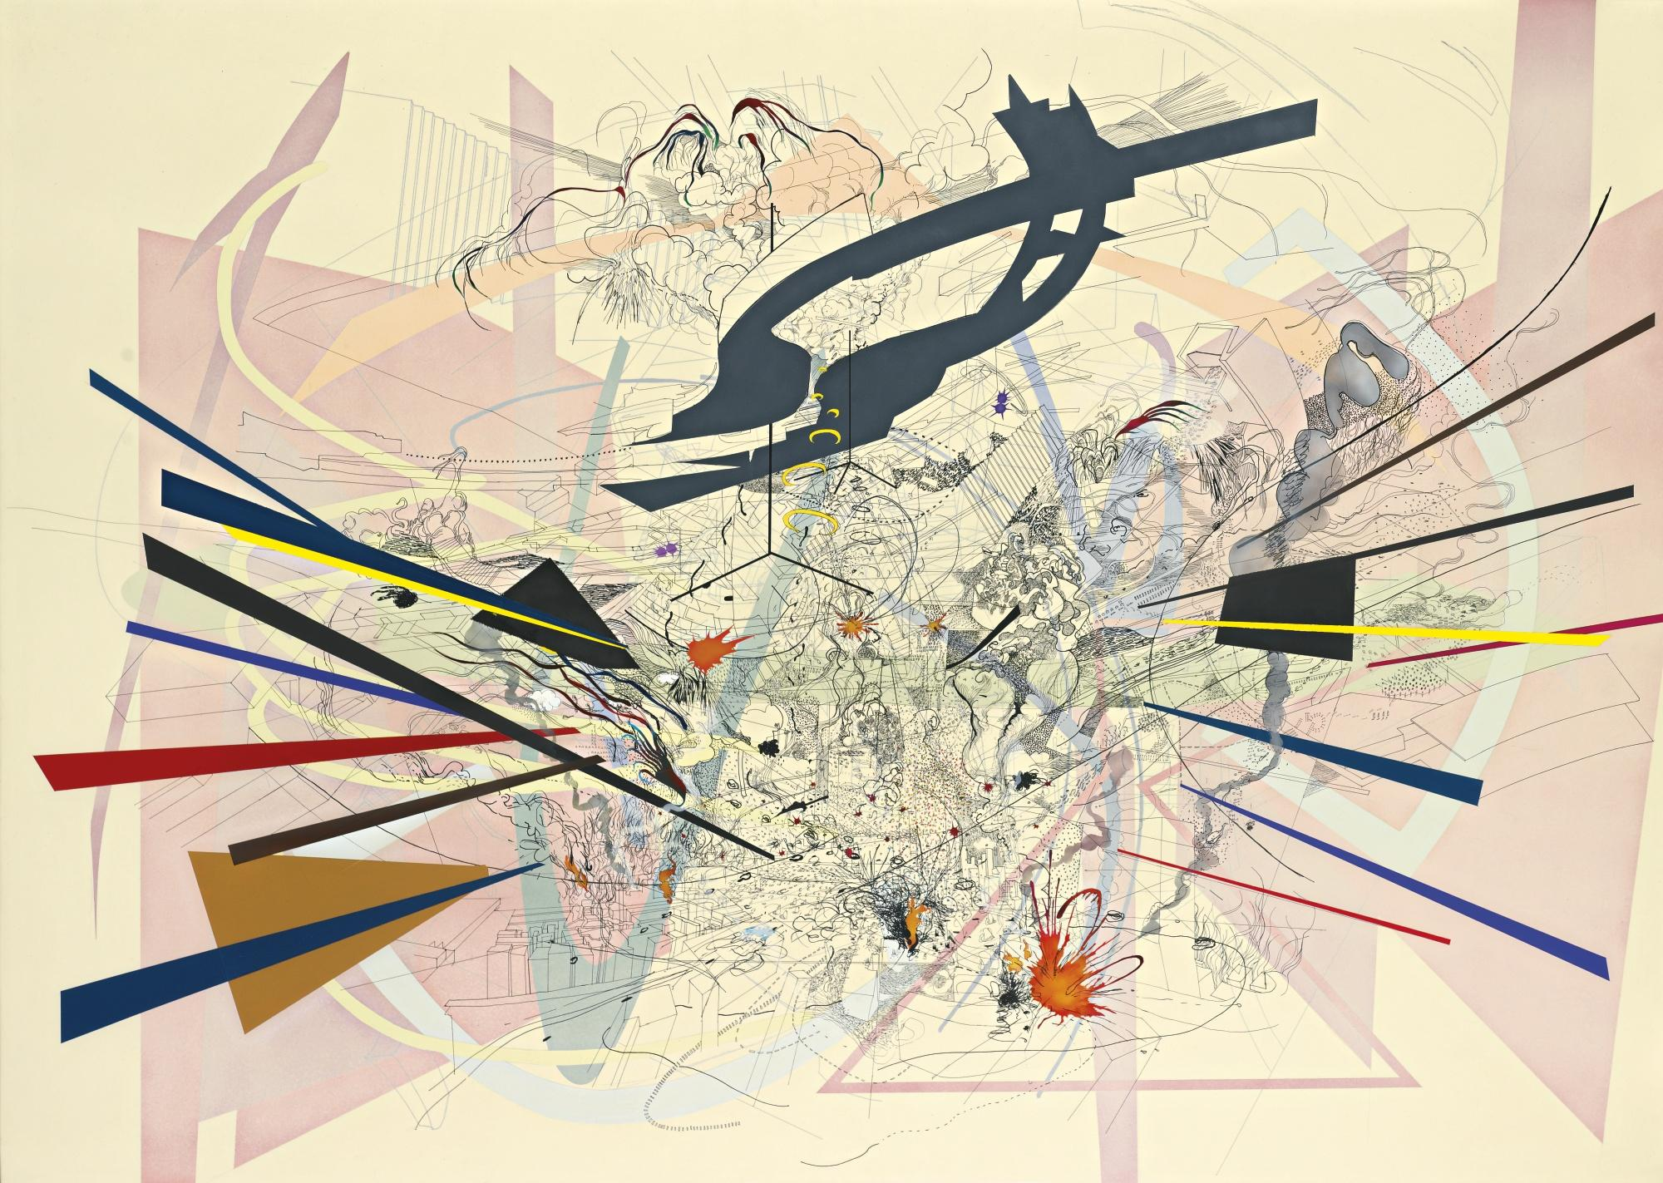

Torey Thornton, How Many Good Pauls Do You Know?

